Week 1 Screenshots of Various Programs

Wade Eckert
Bellevue University
DSC 350: Data Wrangling for Data Science
Professor David Kinney
June 8, 2025

Miniconda and Python
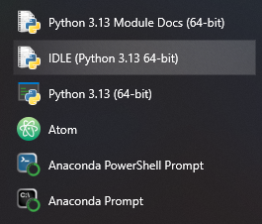
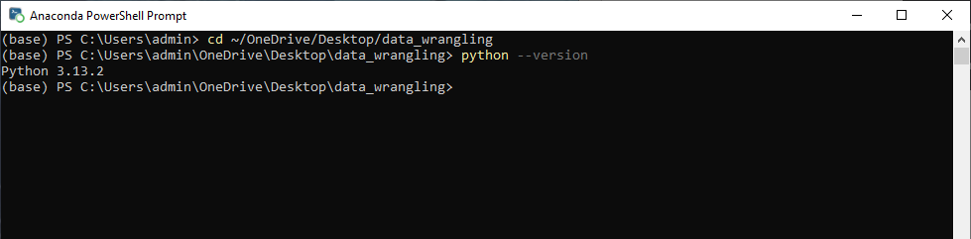

Jupyter
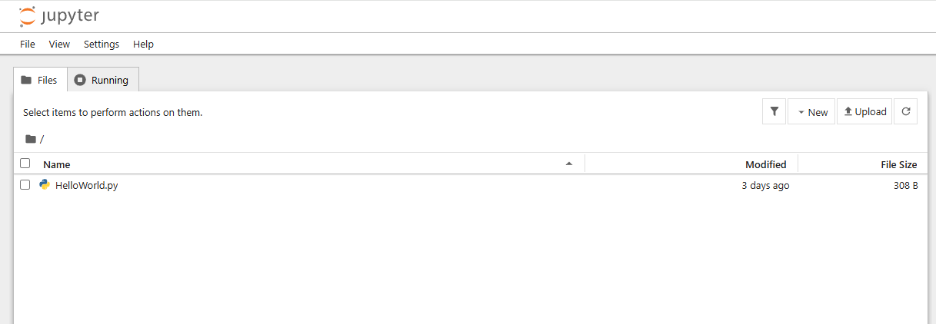
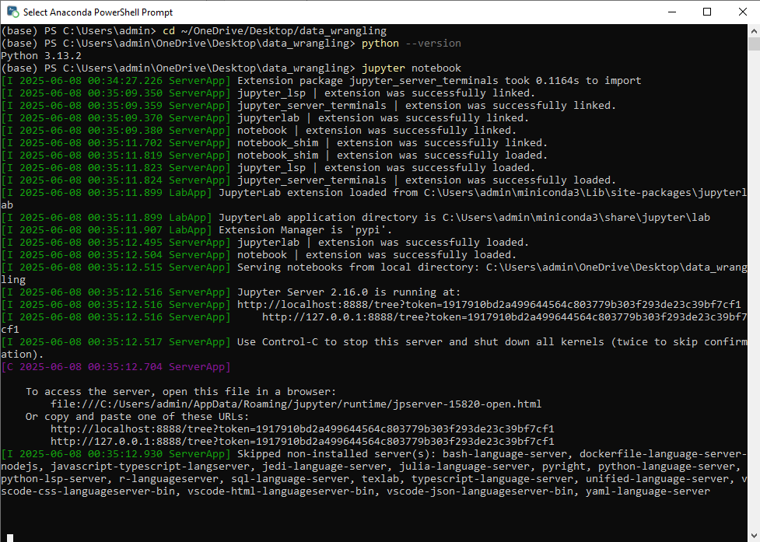
Atom
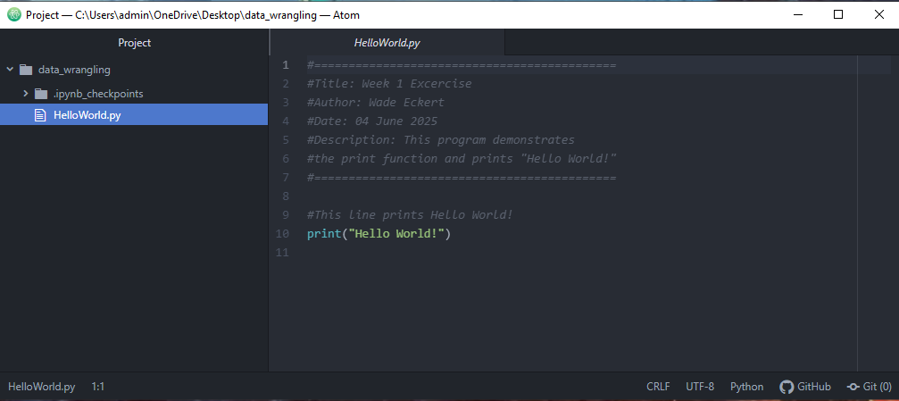

GitHub
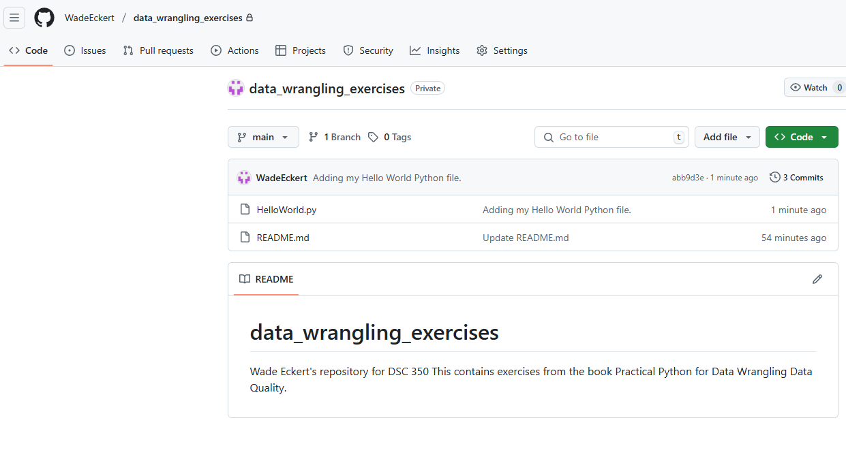
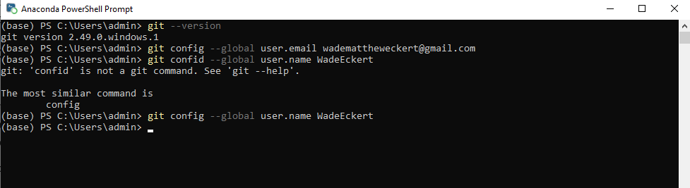Cloned Code from Textbook